IoT Wi-Fi + BLE 4-Layer PCB

Pinanshu Ganesh Surve

Table of Contents
- Introduction
- Overview of the Design
- Root Page 1
  - USB C Connector
  - Lipo Battery Charger
  - Low Voltage Drop (LDO) Regulator
  - Power Indicator LED
  - Battery JST Connector
- Page 2 - Microcontroller
  - USB Module
  - ESP32 - C3 – 02
  - SD Card Module
  - Flash Memory
- Page 3 - Sensors
  - BME280
  - Photo Sensor
  - Microphone and Amplifier
- Page 4 - USB Interface
  - OLED Display Connector (I2C)
  - Breakout for Remaining Pins
  - Reset and Boot Buttons
- PCB Editor
- Final PCB Routing
- 3D Design
- Conclusion

- INTRODUCTION
This project demonstrates the entire process of creating an IoT development board of professional quality using the ESP32-C3 microcontroller.
Ensuring reliability, manufacturability, and practical usability in real-world IoT applications was just as important as integrating multiple modules like power management, memory expansion, and sensor interfaces into a small form factor.
The project's use of a 4-layer PCB architecture results in enhanced signal integrity, decreased electromagnetic interference, and stable power distribution all of which are essential for wireless communication boards.
From component selection and schematic capture to intricate PCB layout and routing to file preparation for manufacturing and assembly, the workflow proceeded in a methodical manner.
Every choice, whether it had to do with component placement, signal conditioning, or power regulation, was made by striking a balance between industry best practices and real-world limitations like component availability and cost.

- Overview of the Design
Each of the four functional layers that make up the ESP32 IoT PCB has a specific function.
- Top Layer: Setting up important parts and directing fast signals like SPI and USB.
- Inner Layer 1 (Ground Plane): A dedicated ground plane that reduces noise and guarantees a stable reference.
- Layer 2 (Power Plane): 3.3V, 5V (USB), and battery voltages are distributed throughout the system by Inner Layer 2 (Power Plane).
- Bottom Layer: Provides extra room for connectors and supporting passives while routing secondary signals.
This layered design offers thermal dissipation pathways, lowers electromagnetic interference, and simplifies routing.
Power management, the microcontroller core, memory, sensors, and user interfaces were all divided into separate functional pages in the schematic.
This modular approach facilitates iterative design refinement, improves clarity, and makes debugging easier.

- Root Page 1
The ESP32 IoT board's power foundation is the sole focus of this schematic page. It assembles the circuits required to receive power, control it, and distribute it consistently throughout the PCB. Inputs: A LiPo battery via the JST connector or a USB-C connection can supply power.
Battery Charging: The device can function while charging thanks to the LiPo charger IC, which controls safe charging by smoothly alternating between USB and battery power.
Regulation: The input (5V or battery voltage) is transformed into the steady supply needed for the ESP32 and all of its peripherals by a 3.3V LDO regulator.
Status Indication: Additional LEDs from the charger circuit show the battery's charging status, while a power LED verifies when the system is powered on.

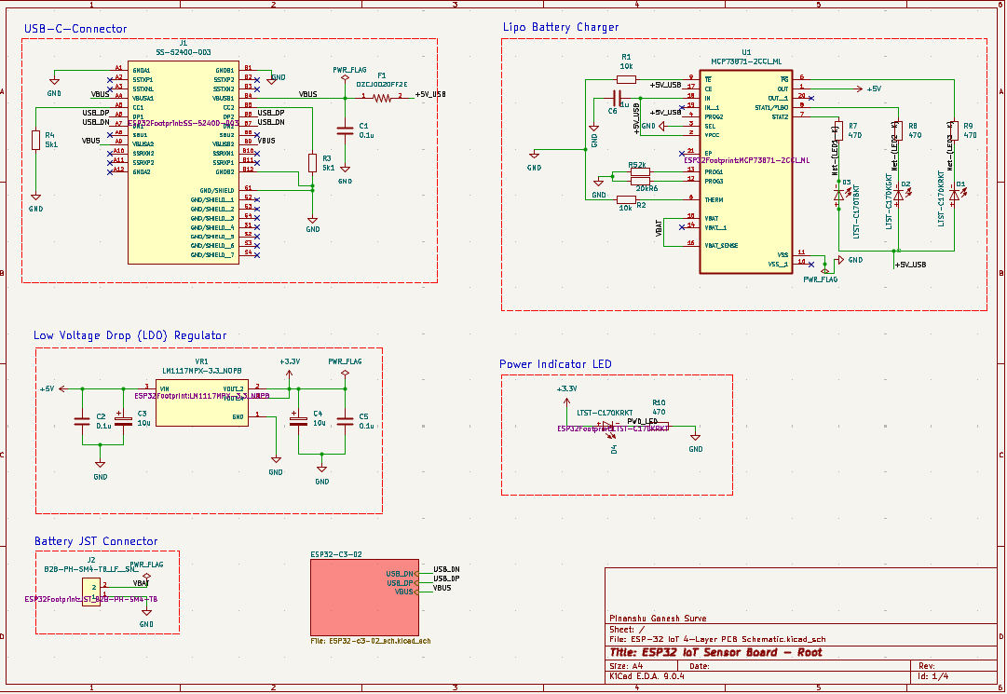
Figure 1. Root Page 1 Schematic
The board's primary power management system is established on Root Page 1. It guarantees that the ESP32 and linked sensors receive a clean, steady 3.3V supply with unambiguous visual indicators of system and charging status, whether powered by a battery or USB. The MCU, sensors, memory, and display, as well as the rest of the circuit, are all made possible by this sturdy backbone.
  - USB Type-C Connector
Because of its durability, reversible orientation, and compatibility with modern devices, the board uses a USB Type-C connector.
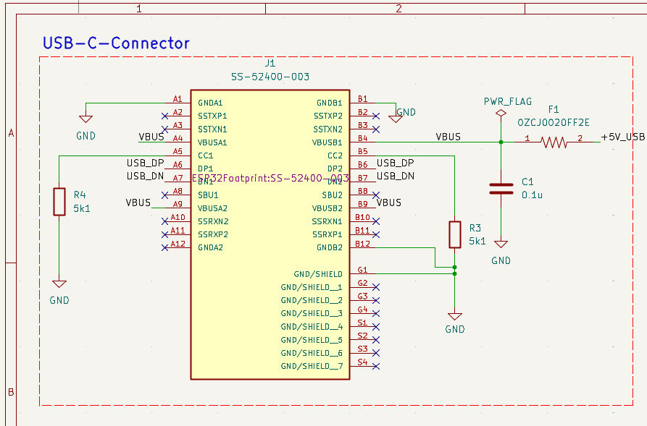
Figure 2. USB Type-C Connector Schematic
It facilitates data transfer and power delivery, allowing for firmware flashing and serial debugging. ESD protection components were added to prevent voltage spikes during hot-plugging, and the USB data lines were routed as controlled impedance differential pairs to preserve signal integrity.
  - Lipo Battery Charger
When using a rechargeable cell, a specialized Li-Po charging circuit guarantees secure charging and discharging. In addition to providing overcharge protection, the charger IC controls constant current/constant voltage charging.
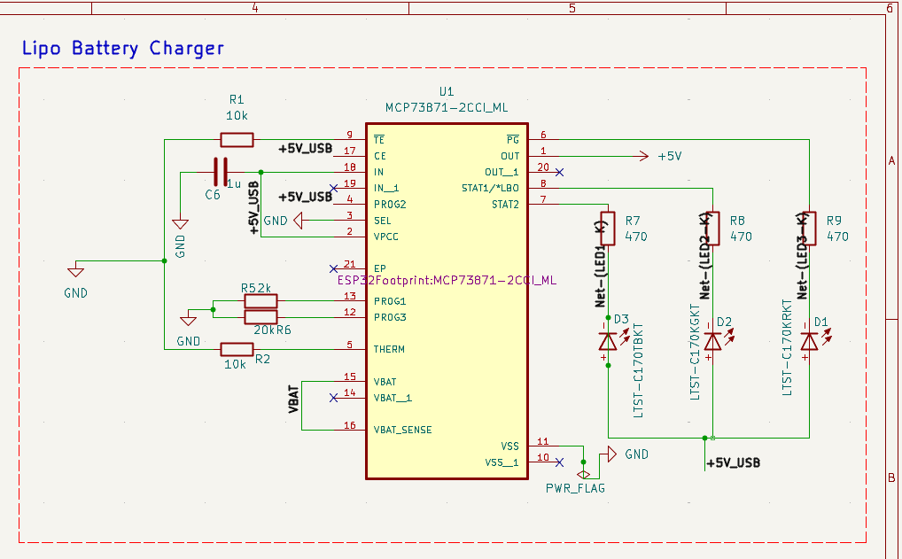
Figure 3. Lipo Battery Charger Schematic
Because of its portability, the board can be used in locations without mains power.
Wide copper pours for effective current handling were used to carefully control thermal dissipation close to the charger IC.

  - Low Voltage Drop (LDO) Regulator
A steady 3.3V supply can be obtained from USB or battery sources thanks to the LDO regulator. While providing current for the ESP32 and its accessories, it guarantees that there is little power loss. For stable operation under a range of loads, decoupling capacitors were positioned in close proximity to the output and MCU pins.

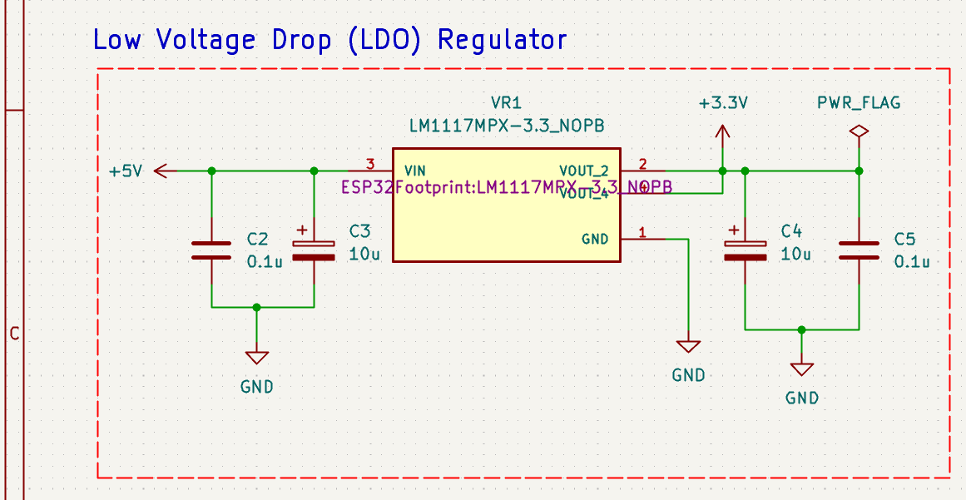
Figure 4. LDO Regulator Schematic
To reduce noise, grounding was optimized using stitching and a solid ground plane.
  - Power Indicator LED
The LED provides instant visual confirmation that the board is powered, which is a basic yet essential feature.

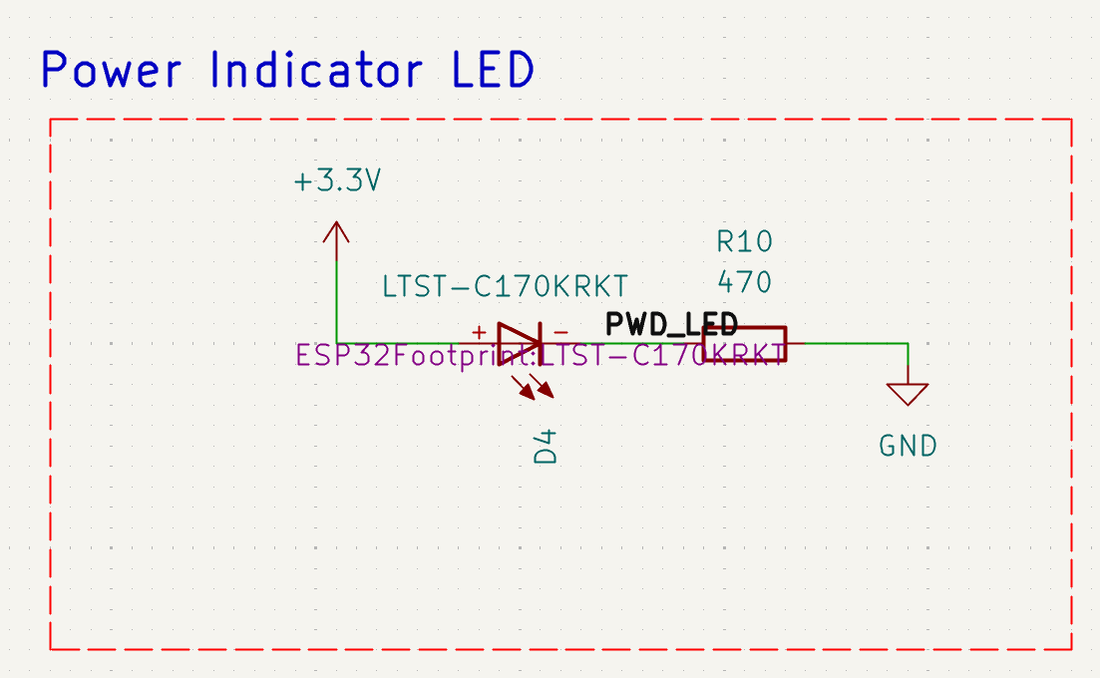
Figure 5. Power Indicator LED Schematic
It speeds up field deployments and helps with debugging. The resistor value was selected to strike a balance between power efficiency and visibility.

  - Battery JST Connector
For LiPo batteries, the JST-PH connector offers a small, dependable connection.

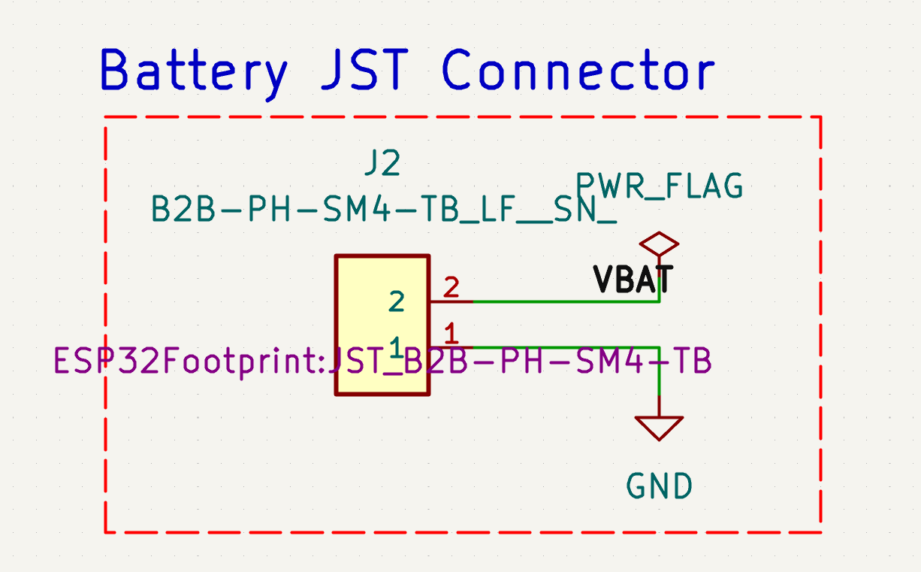
Figure 6. Battery JST Connector Schematic
Its positioning close to the charging circuit ensures effective delivery by lowering voltage drop and routing complexity.

- Page 2 – Microcontroller
This schematic represents the design of an ESP32-C3 based embedded system that integrates USB communication, external memory, and storage interfaces. The ESP32-C3 microcontroller serves as the central processing unit, while supporting components enable reliable connectivity and data handling.
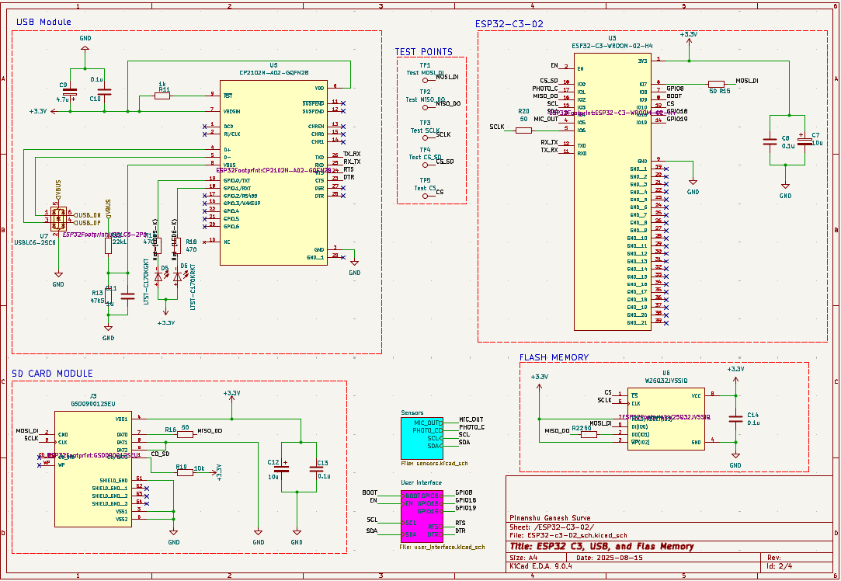
Figure 7. Page 2 - Microcontroller Schematic
A USB-to-UART bridge is used for programming and communication with a host computer, and external SPI flash memory is included for program storage and data logging. In addition, a microSD card interface provides removable storage capability. The design also incorporates test points for debugging, sensor interface connections for expansion, and appropriate decoupling and protection components to ensure stable and noise-free operation. Overall, the schematic demonstrates a modular approach where communication, memory, and interfacing requirements are combined into a compact and robust embedded hardware design.
  - USB Module
The USB module provides the communication interface between the ESP32-C3 microcontroller and a host computer. It uses a USB-to-UART bridge IC (CP2102N) that converts USB signals into serial UART signals, enabling programming, debugging, and data transfer.
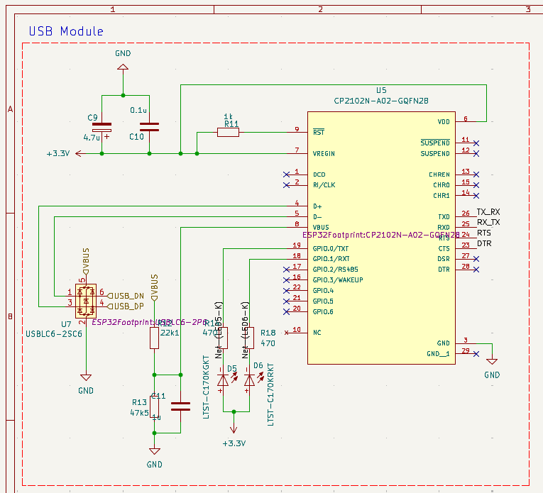
Figure 8. USB Module Schematic
Supporting circuitry includes ESD protection for USB data lines, pull-up/pull-down resistors for proper signal levels, and decoupling capacitors for stable power. This module ensures reliable connectivity and simplifies firmware upload to the ESP32-C3.
  - ESP32 – C3 – 02
At the center of the schematic is the ESP32-C3-WROOM-02 module, which integrates a RISC-V processor, Wi-Fi, and Bluetooth Low Energy (BLE) capabilities. It acts as the core of the system, managing data processing, communication, and control tasks.
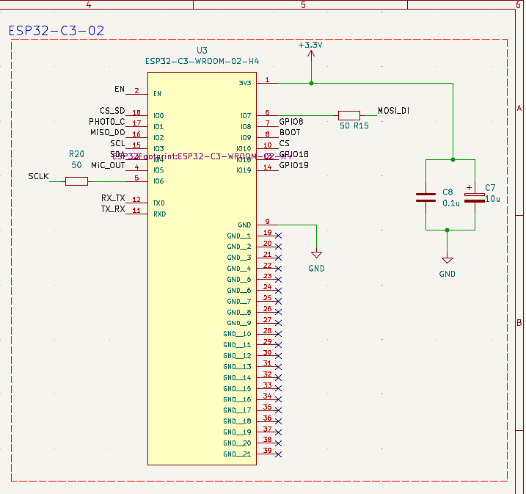
Figure 9. ESP32-C3-02 Schematic
Power decoupling capacitors are included for stable operation, while boot configuration pins allow the system to switch between programming and normal operation modes. Test points are provided for debugging and monitoring key signals, making development and troubleshooting easier.
  - SD Card Module
The SD card module provides removable storage capability for the system, allowing large amounts of data to be stored and easily transferred. It is connected to the ESP32-C3 using the SPI interface and includes series resistors for signal integrity and compatibility.
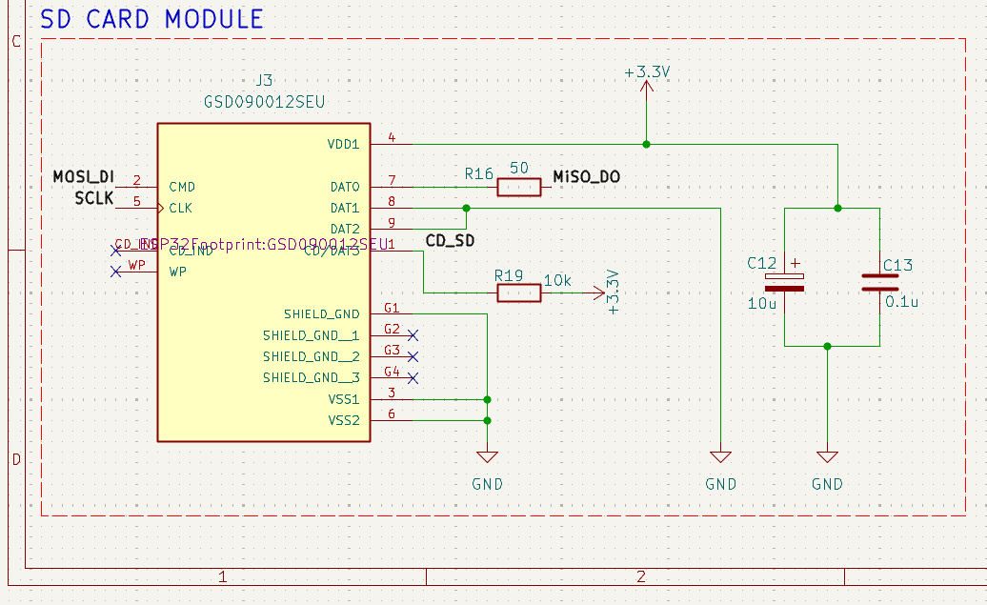
Figure 10. SD Card Module Schematic
Decoupling capacitors are used to stabilize the SD card’s power supply, ensuring reliable read/write operations. This module is particularly useful for applications involving data logging, multimedia storage, or field-updatable configuration files.
  - Flash Memory
The external flash memory section uses a W25Q32JV SPI Flash chip to extend the storage capacity of the ESP32-C3. This memory is used to store firmware, configuration files, or logged data, complementing the internal memory of the microcontroller.
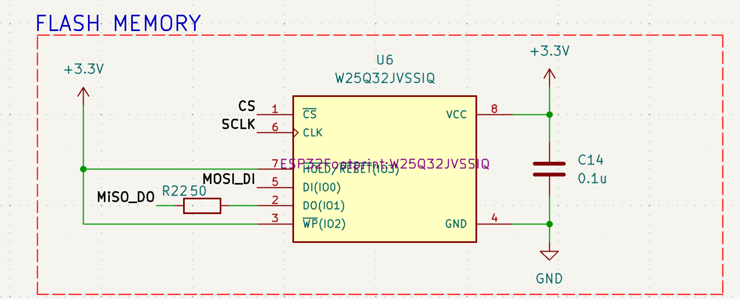
Figure 11. Flash Memory Schematic
The flash IC communicates with the ESP32-C3 via the SPI bus (MOSI, MISO, CLK, CS), and local decoupling capacitors are included to minimize noise. This section enhances the system’s non-volatile storage capability, which is essential for data retention across power cycles.

- Page 3 – Sensors
This schematic represents the sensor interface section of the ESP32-C3 based embedded system. It integrates different types of sensors for environmental monitoring and signal acquisition. The design includes a digital environmental sensor (BME280), an analog microphone with amplifier circuitry, and a light sensor (photoresistor).
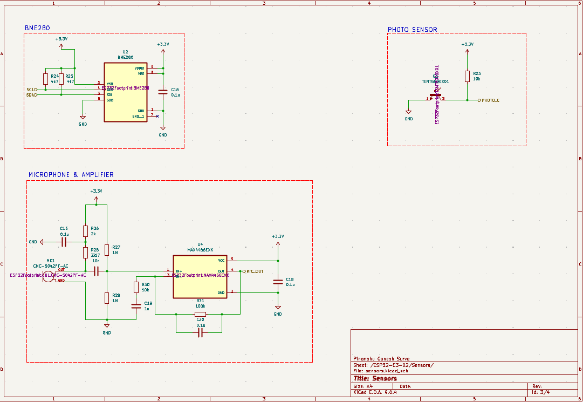
Figure 12. Page 3 - Sensors Schematic
Each sensor is interfaced to the ESP32-C3 either through digital protocols like I²C or through analog/digital GPIO lines. The schematic also includes supporting components such as resistors, capacitors, and amplifiers to ensure proper signal conditioning and stable operation. Overall, this design provides the system with environmental sensing, audio input, and light detection capabilities.
  - BME280
The BME280 module measures environmental parameters including temperature, humidity, and pressure. It communicates with the ESP32-C3 using the I²C protocol through SDA and SCL lines, with pull-up resistors ensuring reliable data transmission.
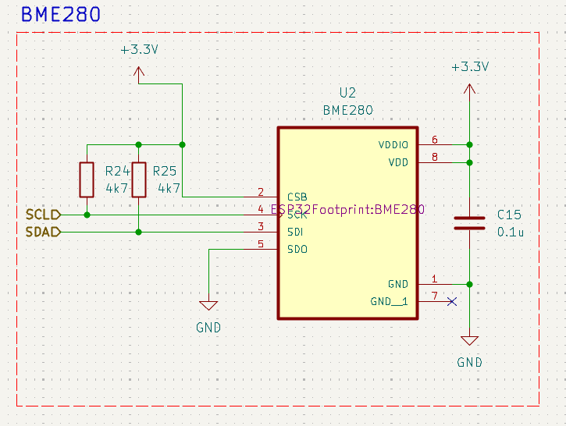
Figure 13. BME280 Schematic
The circuit includes a decoupling capacitor (C15) for power stabilization and additional resistors for signal integrity. This section allows the ESP32-C3 to acquire accurate atmospheric data, making the system suitable for IoT applications like weather monitoring and indoor environment sensing.
  - Photo Sensor
The photo sensor module uses a light-dependent resistor (LDR) to measure ambient light levels. A resistor divider circuit is formed using the LDR and a fixed resistor, with the output connected to a GPIO pin of the ESP32-C3. This produces an analog voltage that varies with light intensity, which the microcontroller can process to determine brightness conditions.
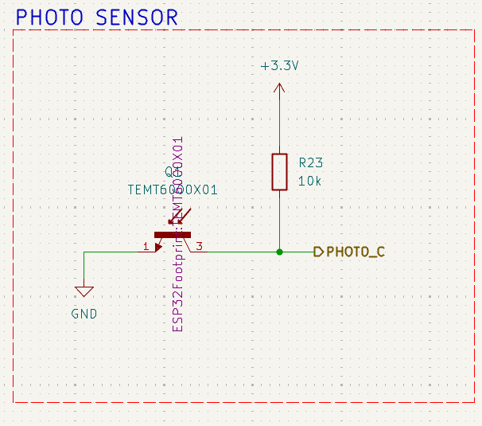
Figure 14. Photo Sensor Schematic
A decoupling capacitor ensures stability of the sensing circuit. This module allows the system to adapt to environmental lighting, useful for applications such as automatic brightness control or light-based event detection.
  - Microphone and Amplifier
This section implements an audio input module using a capacitive microphone (CNC-5027PF) and a MAX4466 operational amplifier. The microphone captures acoustic signals, which are then amplified to suitable voltage levels for the ESP32-C3 to process.
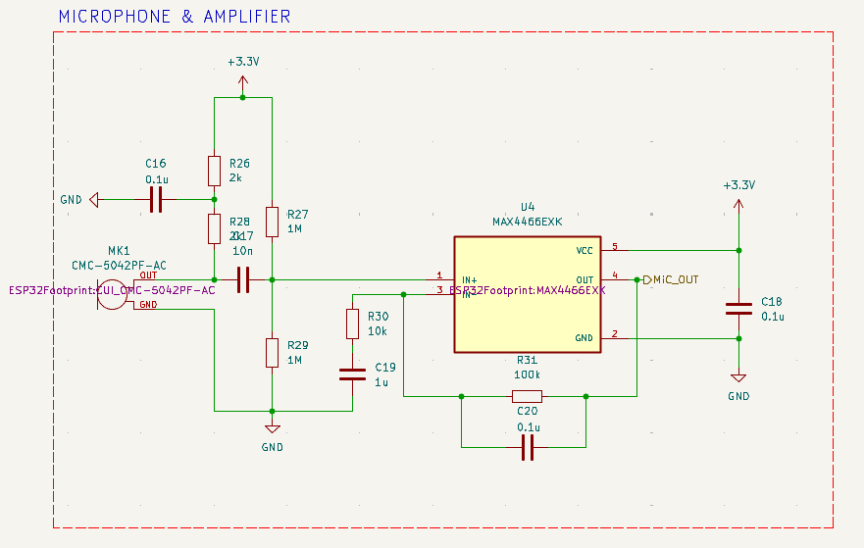
Figure 15. Microphone and Amplifier Schematic
The amplifier gain is set using external resistors, and decoupling capacitors are included to filter noise and stabilize the circuit. The conditioned audio signal is routed to the ESP32-C3 as a digital output (MIC_DUT), enabling applications such as voice detection, audio recording, or sound-based triggering.

- Page 4 – USB Interface
This schematic represents the user interface section of the ESP32-C3 based embedded system. It provides hardware elements that allow users to interact with the microcontroller, including reset and boot control, expansion pin headers, and an OLED display connector. It also integrates an auto-programming circuit that uses control signals from the USB-to-UART bridge to manage the ESP32-C3’s reset and boot modes.
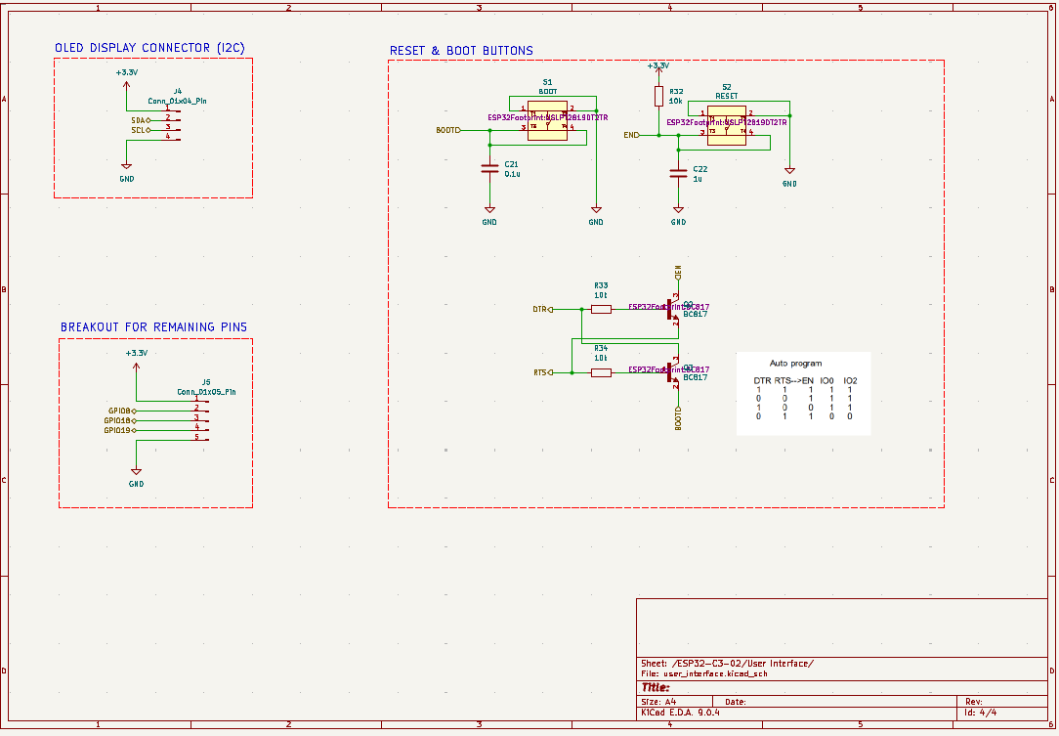
Figure 16. Page 4 - USB Interface Schematic
Together, these components ensure smooth programming, debugging, and user interaction with the system while maintaining expandability for additional peripherals.
  - OLED Display Connector (I2C)
This section provides a dedicated connector for interfacing an OLED display module using the I²C protocol.

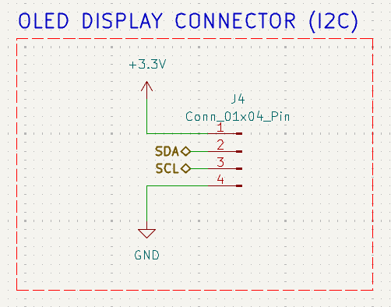
Figure 17. OLED Display Connector (I2C) Schematic
It exposes the SDA and SCL lines along with power (3.3 V) and ground, allowing the ESP32-C3 to communicate with an external display. The connector simplifies integration of a visual output device for data monitoring, debugging, or user interaction.
  - Breakout for Remaining Pins
This section brings out unused GPIO pins of the ESP32-C3 to a header for user access. It includes power (3.3 V) and ground connections along with GPIO8, GPIO9, and GPIO10.
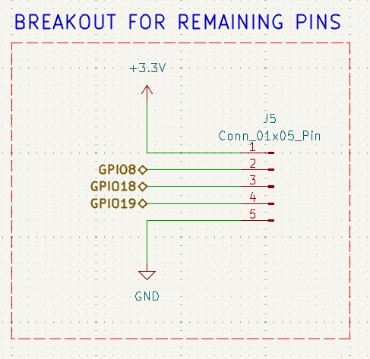
Figure 18. Breakout for remaining pins Schematic
This breakout increases the flexibility of the design, allowing users to connect additional peripherals, sensors, or actuators without modifying the main PCB.
  - Reset and Boot Buttons
The reset and boot button circuitry allows users to manually reset the ESP32-C3 or place it into programming mode. The reset button (S2) is connected to the EN pin, restarting the microcontroller when pressed.
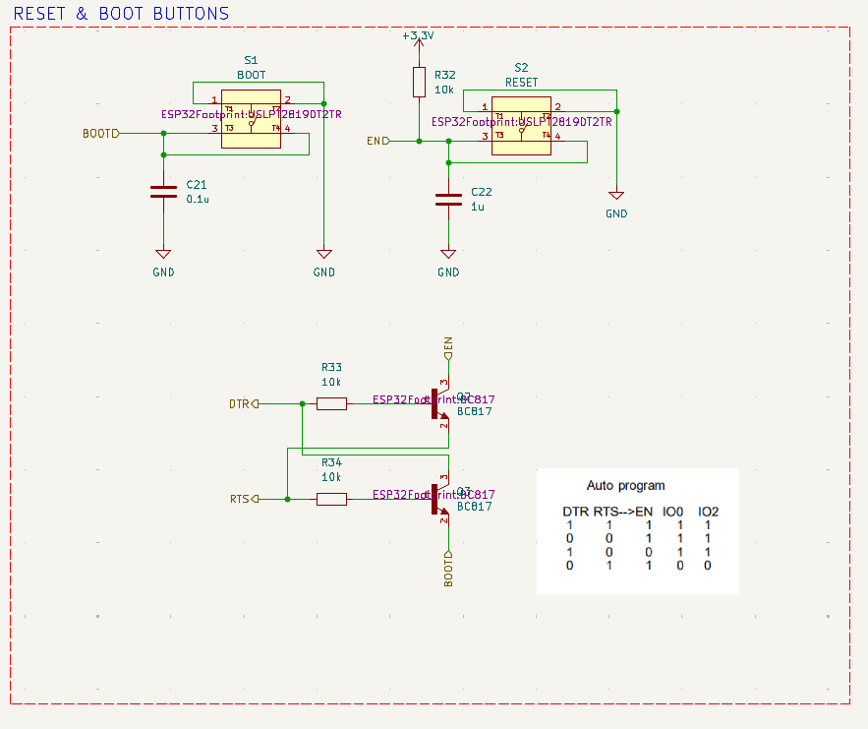
Figure 19. Reset and Boot Buttons Schematic
The boot button (S1) is tied to the BOOT0 pin, enabling entry into firmware download mode when held during reset. Capacitors and pull-up resistors are included to stabilize the signals and ensure reliable operation. This section is essential for development and recovery purposes.

- PCB Editor
Fig. 20 shows the initial layout of the PCB in KiCAD’s PCB editor. At this stage, all the components from the schematic are imported into the PCB workspace and displayed in their default positions.
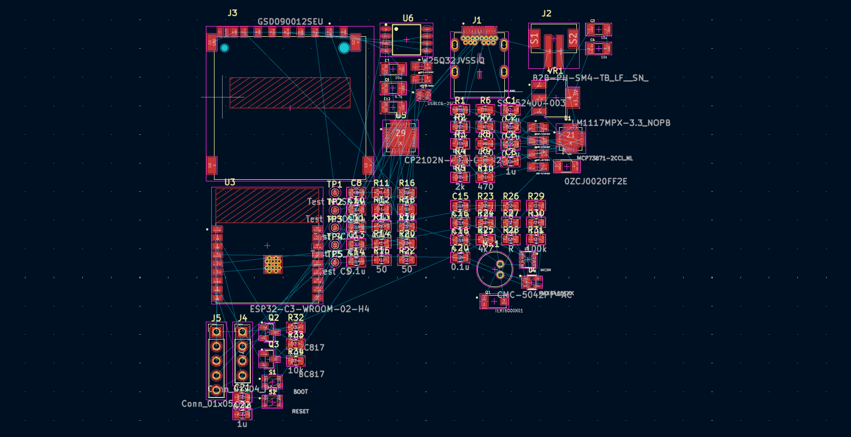
Figure 20. Initial PCB Editor
The components are connected by airwires (ratsnest lines) that indicate the required electrical connections, but no specific arrangement has been made yet. This view represents the raw starting point for PCB design, where the designer must strategically place and route components to achieve an optimized layout.
The Fig 21 illustrates the PCB after component placement has been carried out. In this stage, each component is carefully arranged according to design requirements, signal flow, and physical constraints.
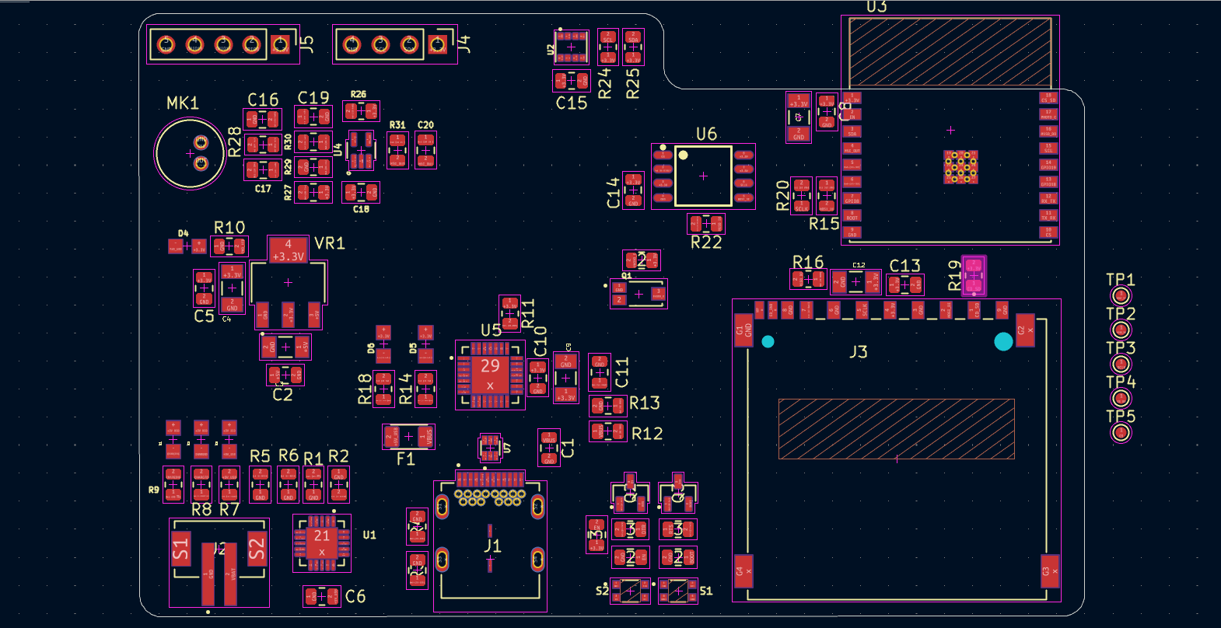
Figure 21. Final Components Placement
Key modules such as the ESP32-C3 microcontroller, USB interface, SD card slot, and sensor circuits are grouped logically to minimize routing complexity and reduce noise. Power supply components are placed close to their respective loads with adequate decoupling capacitors, while connectors and test points are positioned for accessibility. This organized arrangement provides a foundation for the next stage of PCB design, which involves routing the copper traces.

- Final PCB Routing
The completed PCB routing exhibits a meticulously tuned 4-layer configuration tailored for performance and manufacturability. Critical signals, including USB differential pairs and high-speed SPI/I2C lines, are routed with controlled impedance and length matching to maintain signal integrity, while broad copper traces and planes are employed for power distribution to reduce voltage drop and enhance thermal management. Decoupling capacitors are deliberately positioned adjacent to integrated circuits to mitigate noise, while via stitching enhances the ground plane for improved shielding and electromagnetic interference reduction.

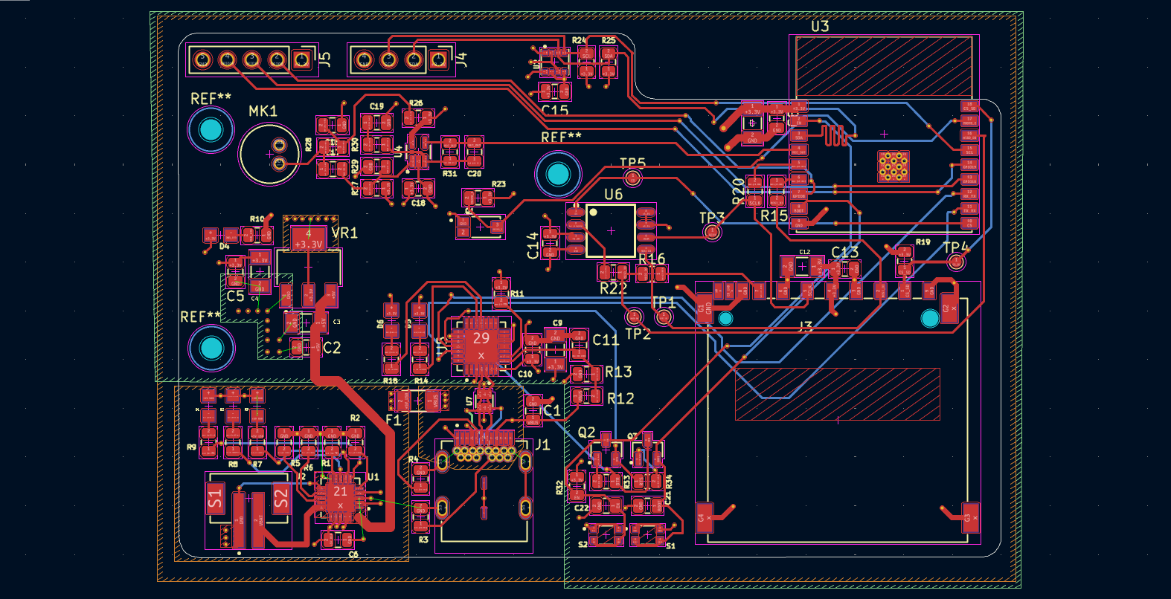
Figure 22. Final PCB Routing
The arrangement of components adheres to a systematic sequence from power entry and regulation to the microcontroller core and peripheral interfaces facilitating brief, direct connections and minimizing crosstalk. The outcome is a small, dependable, and production ready PCB that harmonizes electrical performance, mechanical limitations, and assembly factors.

- 3D Design
Figure 1 depicts the PCB in its preliminary 3D phase, showcasing the board shape alongside all component footprints and copper pads. This stage focuses on verifying the positioning and arrangement of components before assembly. Essential components, including the ESP32 footprint, regulators, connections, and passive elements, are strategically arranged to facilitate logical signal flow and optimize routing.

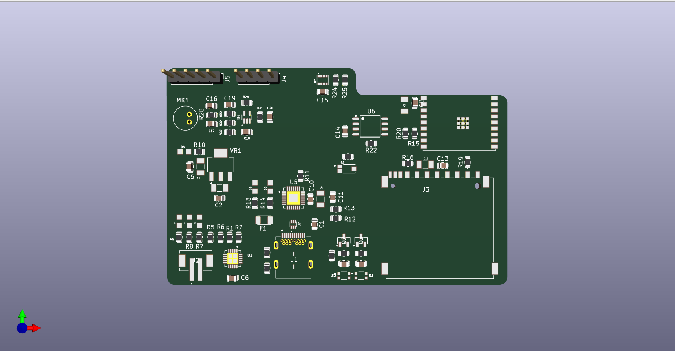
Figure 23. Initial 3D Design
This perspective is particularly beneficial for verifying that components do not overlap, connectors are properly aligned with the board edges, and adequate clearance is available for soldering and manufacturing. Analyzing this intermediate render enables preemptive design alterations, hence reducing the likelihood of expensive revisions later in the process.

Fig. 24 displays the board in its completely constructed configuration, featuring 3D representations of the ESP32 module, USB-C port, SD card slot, and other principal components. This realistic visualization offers a precise glimpse of the PCB's appearance post-fabrication and assembly. It emphasizes the accessibility of user-facing interfaces, such the USB connector and SD card slot, while verifying adequate antenna clearance for optimal wireless performance.

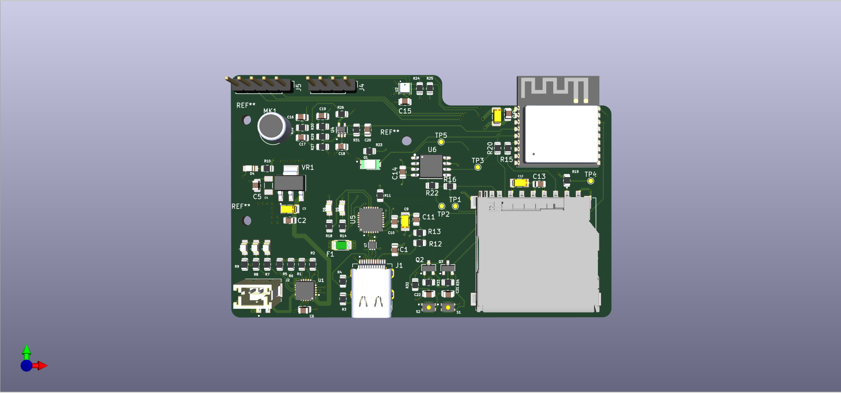
Figure 24. Final Routing Design
This render functions not only as a technical verification but also as a professional presentation tool, showcasing the completed product in a concrete manner. The design is verified to be electrically functional and structurally robust, therefore prepared for practical deployment and enclosure integration.

- Conclusion
The ESP32-C3 IoT 4-layer PCB project exemplifies a comprehensive and professional-grade design of a development board that incorporates processing, storage, sensor, power management, and communication capabilities within a compact and manufacturable configuration. The design features an ESP32-C3-WROOM-02 module as the primary controller, augmented by external SPI flash, an SD card slot, several sensors, and extension capabilities via I²C and GPIO breakouts. A meticulously designed schematic and orderly PCB layout reflect a commitment to functional integration and design excellence, guaranteeing the board's capability to fulfill the demands of IoT prototyping and small-scale deployment.

The power delivery system is resilient, integrating a USB-C input, a LiPo battery charging integrated circuit, and a 3.3 V low-dropout regulator with sufficient decoupling and thermal control. This facilitates consistent performance under fluctuating power situations. Signal integrity has been meticulously managed by controlled-impedance routing of USB lines, ground plane stitching, and the implementation of dedicated power and ground layers, therefore reducing EMI and assuring dependable operation. The integration of sensors like the BME280 for environmental monitoring, an LDR for light detection, and an amplified microphone enhances the board's utility in practical IoT applications. The I²C OLED header and SD card slot augment its expandability.

The design also considers manufacturability and mechanical factors. Three-dimensional verification has been employed to validate component positioning, connector accessibility, and antenna clearance. This measure mitigates the likelihood of mechanical conflicts during enclosure integration and maintains wireless performance. The USB-to-UART bridge, boot and reset circuitry, and accessible test pads facilitate programming and debugging, while silkscreen labeling enhances usability during prototyping. The implementation demonstrates a comprehensive grasp of hardware design principles and practical deployment factors.

Prior to commencing large-scale production, certain enhancements are advisable. The thermal dissipation of the charging IC and LDO must be verified in worst-case scenarios, and ESD/overvoltage protection may be improved by supplementary TVS diodes or input fuses. The incorporation of additional accessible test sites for essential signals would facilitate the initialization and diagnostic processes. The antenna configuration and ground clearance must be verified to vendor specifications to prevent wireless range deterioration. Similarly, the routing of the analog front-end for the microphone and LDR must be segregated from high-speed signals to mitigate noise coupling. These enhancements will augment reliability and facilitate a seamless transition from prototype to production.

In conclusion, the ESP32 IoT 4-layer PCB is a meticulously crafted design that effectively amalgamates many subsystems into a unified platform. It exhibits robust compliance with industry best practices in schematic design, PCB layout, and system integration. The board is prepared for prototype and subsequent pre-production testing following the installation of the suggested enhancements, especially in power, protection, testability, and wireless verification. This establishes it as a multifaceted platform for IoT experimentation, product development, and prospective commercialization.

